Running Zardoz Zord in Waterdeep: Dragon Heist – A DM’s Guide
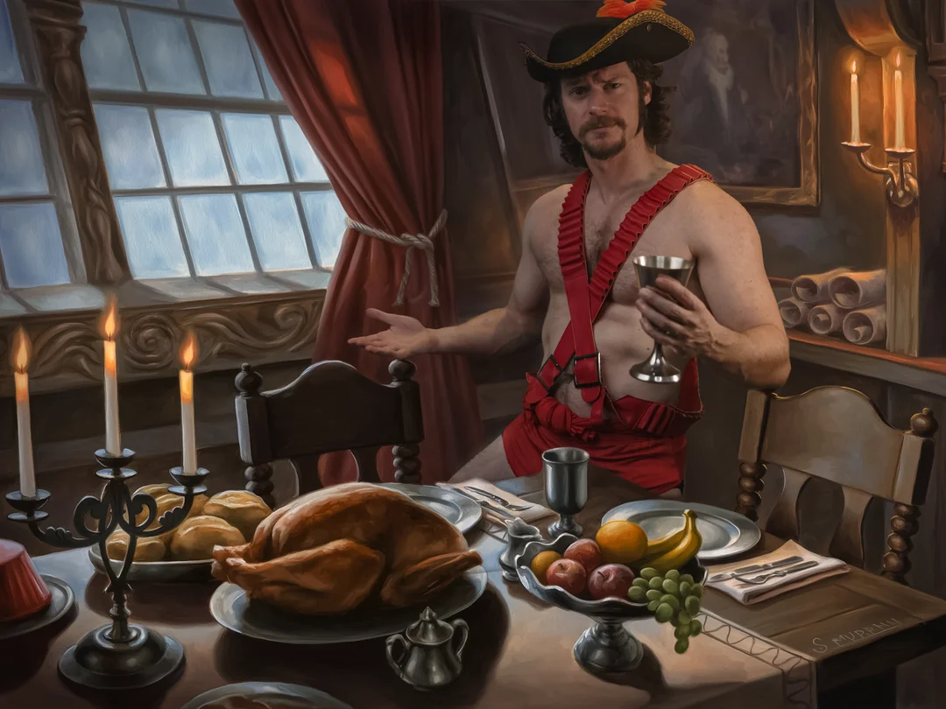
David, The WaterDavian, dressed as Zardoz Zord himself (yes, that’s me 😆)
Zardoz Zord is one of the most entertaining and complex characters in Waterdeep: Dragon Heist. Beneath his flamboyant showman persona, he is, of course, the legendary Jarlaxle Baenre, the charismatic and cunning leader of Bregan D'aerthe. Whether as an ally, rival, or wildcard faction, Jarlaxle can elevate your campaign with political intrigue, espionage, deception, and adventure on the high seas (or at least, Deepwater Harbor).
This guide will provide you with:
- How to Introduce Zardoz Zord to the players.
- Plot Hooks and Quests that involve him.
- How he interacts with major Waterdeep factions.
- How to run him during the events of Dragon Heist before the Jarlaxle reveal.
- A dinner invite, aboard the Eyecatcher (the only shipped anchored in the Harbor)
- His involvement with Nimblewrights, Gladiatorial Games, and espionage.
- A Ledger of all Nimblewrights he has sold so far (including a voided transaction with the Cassalanters). It includes the Nobles houses, Guildsmasters, and other notable citizens of Waterdeep such as Lord Mertonius (Mirt) and the Lord Commander of the Watch (Bob Staget, whom I've promoted from Captain to Commander)

Introducing Zardoz Zord
Zardoz Zord should make a big, theatrical first impression. His entire persona is larger than life, and he is fully aware of how attractive, influential, and dramatic he is.
First Encounter. The Parade:
Zardoz Zord should be introduced during the Day of Wonders Parade (Fall)*, where the Sea Maidens Faire puts on a grand performance in partnership with the House of Inspired Hands (Temple of Gond).
*Note: My campaign was during Fleetswake Festival, the last tenday of Ches (Spring). I replaced the Day of Wonders Parade with the Twin Parades instead, which you can find more info in the Alexandrian Remix here.
He leads the parade on the back of a massive rainbow-feathered Diatryma (summoned using his magical feather) as musicians, acrobats, and caged beasts (notably the Owlbear from the official art) from his ships perform for the crowd. The sheer spectacle ensures the players take notice of him.
Zardoz might even make eye contact with the party if they stand out in any way (which I'm sure they will, yout players consider themselves unique). Whether they are famous, wanted, or part of an organization that intrigues him. Originally I had a player who was a drow that I had planned on him recruiting one of my players who was playing a Half-Drow from the Rosznar family but unfortunately she had to drop out. But don’t miss the chance for him to take notice of any Drow PCs! The module even mentions that if a certain amount of time passes without the party seeking JB out, Jarlaxle will still reach out to any Drow player character to recruit them into the Bregan D’earthe.
Hint at future quest hooks from the Parade:
- The players witness the Temple of Gond and Zardoz exchanging goods, including mysterious golden Nimblewright automatons being purchased by wealthy nobles.
  - I had Valetta, the bronze dragonborn from the Temple of Gond, wanting to thank Zardoz personally for selling him her new Nimblewright, Nim (which later becomes a pawn of the Gralhunds instigating the essential Fireball incident which leads the players to the Stone of Golorr) who performed in the parade
  - Valetta can appear at the end of the parade when the party was checking out the Sea Maiden’s Faire carnival in Mistshore. Valetta wanted to personally thank Zardoz and spoke with the crew of the Heartbreaker to request to join him for dinner. When the party hears this I had Zardoz also invite them, all via a sending stone, but you could very well have him do it in person.
  - If the players don’t visit the SMF carnival in Mistshore and they don’t go to the Parade (or really the Dock Ward in general), you can simply have Valetta be seen walking around Trollskull Alley showing off her shiny golden robot, which should be enough to pique the players interest when she tells them about the fantastical man who sold them to her for a steep discount
- Zardoz calls out to a player, especially if they have a reputation (Gladiators, Nobles, Infamous Rogues, Bards or dancers he could recruity, really anyone with talent).
- A beast breaks loose from the Faire (such as an escaped bear that the modules suggest, or something cooler like a displacer beast) and Zardoz watches to see how the party handles it.
  - This is straight from the module but I didn’t have to use this hook
What Zardoz Wants from the Party:
- To observe their skills and allegiances. He’s not sure whether they are allies or rivals yet, with regards to infiltrating the nobility. He does NOT yet know about the Stone, unless the party tells him about what the Xanathar was after and/or he asks about their recent reputation with rescuing Renaer.
- To measure their usefulness. Jarlaxle is always looking for capable individuals he can charm, manipulate, or work alongside.
- My homebrew: To recruit a skilled gladiator or combatant. He invites them to participate in the upcoming Field of Triumph games as his champion, supplying exotic beasts from his ships.
  - This is only if you want to run gladiatorial games and other fun events in the Field of Triumph. One of my players, Hurk, had the Gladiator background from winning his freedom by fighting for 10 years in the Arenas of Blood, so Zardoz knew how much of a performer and crowd pleaser he was (“Are you not Entertained?!”)
  - You can use the Field of Triumph for a cool little tournament arc that also gains renown for your players and catches the eyes of Laeral, the Zhents, and Xanathar himself who may wish to invite them to his own personal shady underground tournament. The Gralhunds also might see this and want to hire them as mercenaries.
  - Look for my guide in the future for how to run a fun Field of Triump tournament for the team melee, chariot races, rick shaw races, the Kobold Shoveball World Series, and the Talent Show for those not interested in combat or violence.

The Dinner Invitation – Boarding the Eyecatcher
Once the players have caught Zardoz’s attention, he invites them to dine aboard his personal flagship, the Eyecatcher, anchored in Deepwater Harbor.
Note: For my campaign, I kept teasing at how excited everyone was for the Fleetwake Festival and Sea Maiden’s Faire. But the real reason they ultimately headed that way was when they investigated the Elf Killer (See my Davil Starsong guide) and found one of the most recent victim was a sailor with a Kraken’s Folly tattoo.
Now, the tattoo itself mattered not, but it got them asking around the docks of Mistshore for any sailors who may have known who was part of this crew. The sailors told them that their captain, Zardoz Zord, would surely know who this guy was - but secretly they are drow in disguise and know that they should be sending the players to Zardoz (Jarlaxle) for questioning since they probably can put two-and-two together that it’s one of their own involved in the killings.
I also baited them to check out docked docked Heartbreaker and Hellraiser by having them hear dinosaur noises (playing the raptor and t-rex noises) with a Perception Check. Knowing one of my players was a massive dino lover made him instantly want to check out the Hellraiser where they stored the floats and animals. This is when they encounter Valetta talking to the crew of the Heartbreaker.
The invitation could also simply be delivered by one of his drow spies disguised as a human or via a mysterious black pouch of coins with a note written in extravagant calligraphy:
"Zardoz Zord cordially invites you for an evening of fine dining and entertainment aboard the Eyecatcher. Bring your appetite, and perhaps, your curiosity. A dinghy will be waiting for you at the Dock Ward at sundown. –ZZ”

Aboard the Eyecatcher – The Ultimate Showman
The Eyecatcher’s dining cabin is an over-the-top display of wealth and indulgence:
- Golden filigree, perfumed wood paneling, and purple velvet curtains.
- A massive feast of exotic meats, fine wines, and decadent desserts (courtesy of Chef Boyardee, which of course hints at the French accent of Jarlaxle)
- Drow crew members magically disguised as handsome and beautiful human attendants.
- Music and entertainment, including illusionary performances or even a private show of swordplay.
How Zardoz Acts:
- Zardoz is clearly an homage to the bizarre acid trip of a movie starring Sean Connery, so I tried to use the Sean Connery accent (even one of the pirates on the Hellraiser introduced himself as Canary, Shawn Canary as another inside joke)
- Confident and extravagant, carrying himself like a noble pirate king.
- Flirtatious, with an eye for strong warriors or beautiful individuals.
- Deflects all direct questions about Waterdeep’s politics as if he isn’t interested, hopefully arousing suspicion in the player for even mentioning politics / nobles
- Shows off this collection of Nimblewrights saying they will do anything you ask (arousing suspicion in my party if they could be ordered to kill like the Elf Killer)
Conversation Topics:
✔ The Sea Maidens Faire is a traveling carnival from Luskan, bringing exotic entertainment to Waterdeep.
✔ He sells Nimblewrights to the city’s wealthiest noble families—“The finest servants in all of Faerûn.” (He sells them at a steep discount, any insight or history check can reveal this price is a steal and suspicious).
✔ He is interested in talented warriors, offering sponsorship for the Field of Triumph games. He’s looking to sponsor up and coming talent and champions of the people to curry favor with the lords and ladies of Waterdeep, as well as the Open Lord herself. His ultimately wants the city of Luskan to join the Lords Alliance and will be looking to change people’s minds about Luskan in general.
✔ He pretends to have no interest in the Stone of Golorr if it is mentioned (but this is a lie).
Secret: The Nimblewright Spy Network
In reality, the Nimblewrights sold to the nobility are acting as spies, feeding Jarlaxle secret information about Waterdeep’s elite via built-in scrying devices.
- If the party uncovers this, Zardoz attempts to manipulate them into keeping quiet or persuade them to work with him.
- If they confront him directly, he remains calm, amused, and impressed.

Zardoz’s Connection to the Field of Triumph
Zardoz is supplying exotic beasts for the upcoming gladiatorial games in the Field of Triumph.
If the party has a Gladiator or Fighter, Zardoz offers to sponsor them.
The Xanathar spies on these events, looking for strong recruits. This could bring Xanathar’s Guild into the mix.
Jarlaxle secretly uses the games as an opportunity to meet powerful people without suspicion.
He also can feed the Players lies about Zardoz (really himself) smuggling illegal creatures to the Xanathar for Xanny's bloodmatches in Skullport, selling illicit magic items, banned substances etc. You can see more of that in my Jarlaxle guide (link will be posted end of December 2025).
Creatures He Provides for the Games:
- A Displacer Beast or Panther
- A Triceratops or Allosaurus (below deck on the Heartbreaker)
- Diatrymas (giant colorful prehistoric birds from the Underdark)
- Owlbears
- Raptors
- Any exotix creatures that might be even more dangerous to have in the city proper (aka Abberations, Monstrosities) he could actually sell to the Xanathar Guild for their sick games they play. Either as a real transaction or as a sting operation.

Running Zardoz Zord in Your Campaign
- Zardoz Zord should be:
- A charming manipulator
- He rarely fights unless necessary.
- A wildcard. He can be an ally, a rival, or a powerful patron.
- A source of intrigue and deception.
- His Nimblewright network is spying on Waterdeep’s nobility.
- An opportunity for players to gain influence
- Siding with Jarlaxle provides access to rare magic, mercenaries, and resources.

Final Thoughts
Jarlaxle Baenre, disguised as Zardoz Zord, is one of the most fascinating villains (or allies) in Dragon Heist. By running him as a suave, intelligent, and theatrical presence, you can create memorable encounters that feel like something out of a high-stakes fantasy espionage novel.
If you want a flamboyant rogue who can both help and hinder your players, Zardoz Zord is the perfect NPC to keep them guessing every step of the way.
Once the players begin the Grand Game Zardoz will reveal himself to be Jarlaxle. Stay tuned in the future formy Jaraxle guide, which includes dialogue for how to have himself be revealed aboard the Eyecatcher or during the Elf Killer investigation. Also be sure to check out my guide to Deepwater Harbor and Zelifarn the Bronze Dragon who wants to gets access the the crystal ball JB has hidden under his ship. And of course, I’ll cover how to do the Heists with or without JB, and a cutscene for him taking out his own loose cannons during the Elf Killer arc.

APPENDIX A:
Zardoz Zord's Ledger of Commissioned Automata
Model: Nimblewright personal assistant
Design: Made in Lantan
Recorded by: Harbourmaster’s Registry of Mechanical Servitors
Clerk on duty: J.S. (Jalaster Silvermane)
- Lord Labdar, of House Adarbrent
Unit-BD004 House Adarbrent, Master Mariners Purpose: Front-hall sentry, Domestic attendant and courier Delivery: Adarbrent Villa, Sea Ward. REC-0003. Appearance note: Onyx oculars. House tabard fitted.
- Lord Luth, of House Ammakyl Unit-BD005
Purpose: Farm and granary steward, vinters security Delivery: Ammakyl granaries, Trade Ward offices. Programming: Tally ledgers, pulley hoists, grain-sifting routines, forensic toxicology
- Lord Ammalia of House Cassalanter
Unit-BD003 Status: Entry voided by client Notes: Contract withdrawn. Deposit returned per clause 2A during PoS.
Standard 100 gp Fees retained for design consult. Ref # INV-542.
- High Priest Valetta, of Temple of Gond - House of Inspired Hands
Unit-BD007 Purpose: Workshop aide and demonstrator Gond's glory Delivery: Inspired Hands courtyard. REC-0007. Appearance note: Layered feather “hair.” Clerk note: Client provides their own detectors and tools. None supplied under this contract.
- Lord Orond and Lady Yalah, House Gralhund -
Unit-BD006 Purpose: Household valet and grounds attendant Delivery: Gralhund Villa, North Ward. DEL-0279 signed by head butler. Finish: Ironwood plating with brushed-steel trim. House monogram approved (OG). Service: First calibration visit scheduled.
- Lady Alvilda of House Margaster
Unit-BD009 Purpose: Coachman and stable assistant Delivery: Margaster Coach House, North Ward. REC-0011. Programming: Coach-hand protocols, traffic ward signals, whistle response. Note: Polished brass fixtures requested to match carriage lanterns.
- Lady Master Bowgentra Summertaen, of the Watchful Order of Magists and Protectors
Unit-BD010 Purpose: Guildhouse majordomo and doorkeeper Delivery: The Order’s Guildhall. DEL-0194. Appearance note: Smooth featureless head per patron’s request.
- Lady Cassandra of House Thann
Unit-BD002 Purpose: Cellar and vineyard porter Delivery: Thann Villa and bonded warehouse. DEL-0006. Programming: Fragile-crate handling, bottle etiquette, humidity checks, forensic toxicology of wine samples.
- Lord Commander Hyustet Robert Staget III, City Watch, Dock Ward Precinct
Unit-BD005 Purpose: Patrol and gatehouse relief Delivery: Watch House Armory, Ship Street. DEL-0023. Programming: Fencing partner, master of arms, whistle codes, crowd-control stance.
- Lord Mertonius of Waterdeep
Unit-BD001 Purpose: Mansion steward and gallery attendant Delivery: Hexagonal manse near Coin Alley and Tarnished Silver Alley, Mount Waterdeep. REC-1012. Wardrobe: Fittings adapted for Lord’s Ensemble. Access tokens logged

DM's Glossary (Don't show this to players)
DEL = Delivered
REC = Recieved
BD = Bregan D'Earthe
Mertonius = Mirt's legal name
Hyustet Robert Staget = Bod Staget
(I elevated Captain Staget to Lord Commander of the Watch and made him a bit of a stiff jerk subservient to the Cassalanters and/or the Nobility)

